YI862 - CIP – Judicial Dashboard
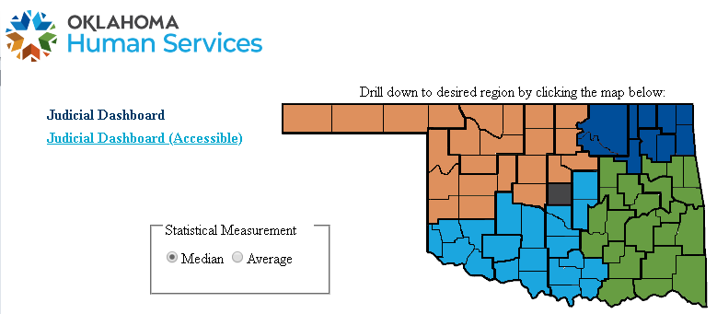

At the top is a map that allows the user to select the Region / District / County. Users can hover over the map to select the desired Region / District / County. When selcted, the measures below will update to reflect the data pertaining to the selected area. The Dashboard can drill down from Region, to District, to County levels.

If the user wishes to return to the statewide level data after drilling down, a link appears at the top left and can be clicked on and the measures and map will refresh back to the statewide data.

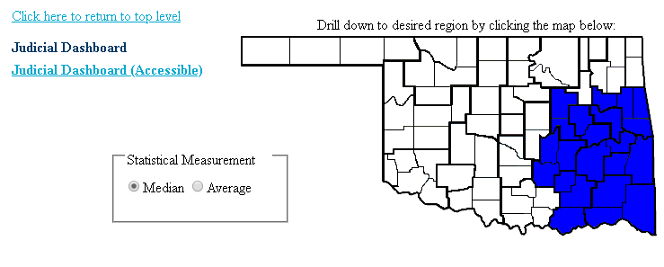

The dashboard also includes the option to select which statistical measurement is used for the data: Median or Average. The charts are default set to display the Median as shown above.

There is a link at the top left that will display all of the data numberically in tables for 508 compliance.

Data Notes:
- Most measures run on a 30 day lag (unless noted otherwise).
- Period Under Review (PUR) – most measures cover a 12 month period (unless noted otherwise).

Measure 1.1 – Days from removal to Adjudication Date
- This measure includes all children where child’s removal begin dates falls during period under review (PUR) prior (12 month period unless stated otherwise)
- Difference between days from Removal Begin Date to Adjudication Date

Measure 1.2 – days from Removal to 1st permanency Hearing
- This measure includes all children where child’s removal begin dates falls during (PUR)
- Difference between removal begin date and 1st permanency hearing
- A permanency hearing includes the following hearing types:
- Adjudicatory*
- Termination
- Permanency
- Pre-Trial - Child's Permanency Reviewed
- Adjudicatory-Child's Permanency Reviewed
- Termination-Child's Permanency Reviewed
- *To be counted as a Permanency hearing, date must be after or equal to Adjudication date. If same date, disposition must have occurred at Adjudication.

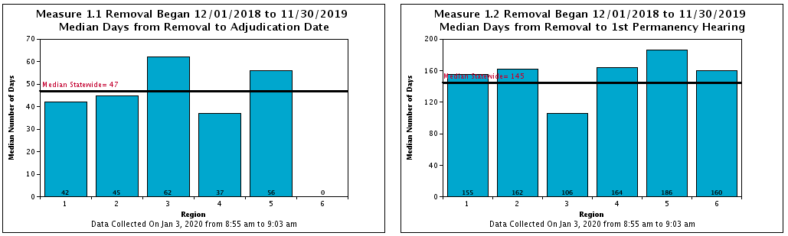

Measure 2 – Children Exiting to Permanency
- This measure includes a count of all served children in care during the PUR and a count of those children exiting to permanency during PUR
- Permanency Exit Reasons include:
  - Adoption or Adoption / Tribal Jurisdiction
  - Guardianship – Relative or Non-Relative
  - Reunification
  - Custody to Relative

Measure 3 – Time to Permanency – Days between Removal and Exit
- Removal End Date during PUR with an exit reason of:
  - Adoption or Adoption / Tribal Jurisdiction
  - Guardianship - Relative
  - Reunification
  - Custody to Relative
  - Guardianship - Non-Relative
- Length of time in days between Removal Begin Date and Removal End Date
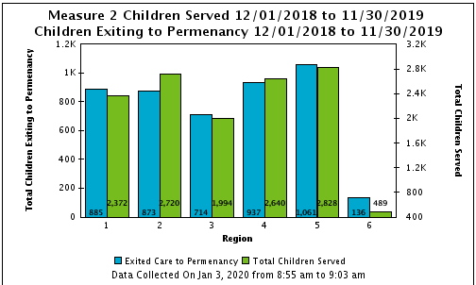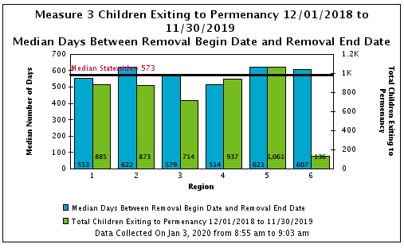

ADOPTION MEASURES:
Measure 4.1
- All children with a case plan goal (CPG) change to Adoption during PUR, (recommendation of Termination of Parental Rights (TPR) to court)
- length of time from Removal Begin date to date of CPG to Adoption

Measure 4.2
- All children who become Legally Free during PUR (“Legally Free” is termination of parental rights for all applicable parents)
- length of time from date CPG established as Adoption to Legally Free Date (TPR)

Measure 4.3
- All children with a Removal End date in PUR who exited care to Adoption
- length of time from Legally Free Date to Removal End Date (Exit)

Measure 5
- Removal End Date during PUR to Adoption Finalization date
- length of time from Removal Begin date to removal end date (total time in care)

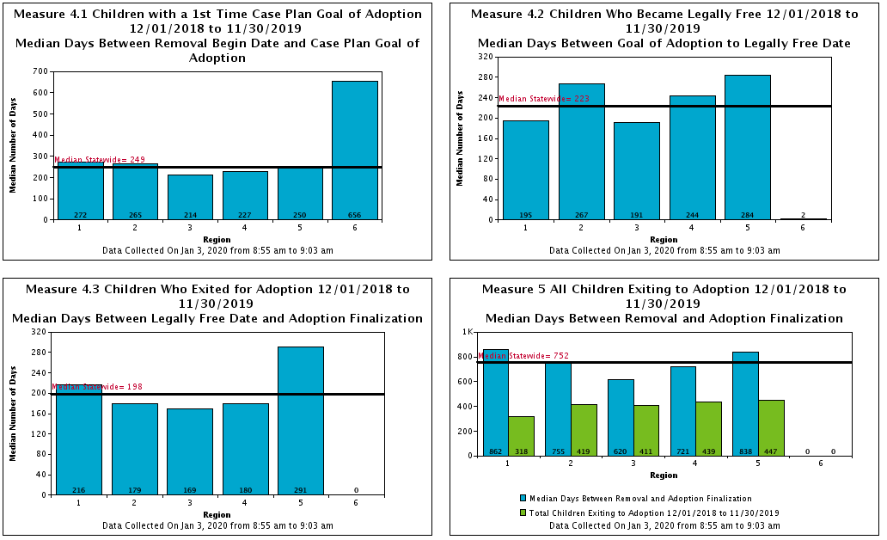

Measure 6 – Re-Entry
- Percentage of children with a previous removal end date within 12 months of current removal begin date
- Standard is above 91.4% without a previous removal
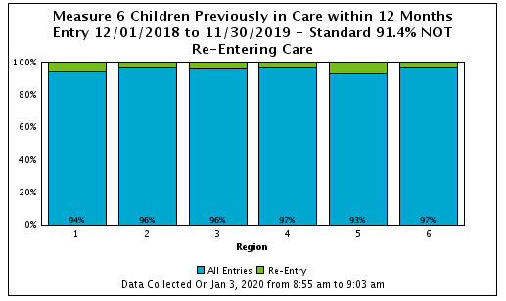

Measure 7 - MIC
- Children Maltreated in Care by Foster Parent or Bio Parent during prior 12 month period
  - Can select perpetrator as Foster Parent, or (Bio) Parent

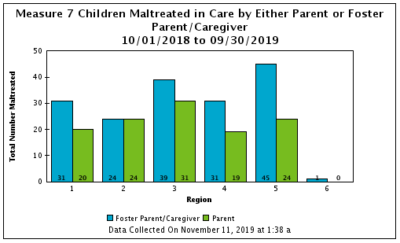

Measure 8 – All Exits from Care
- All children who exited from care during PUR and includes all children exiting care.

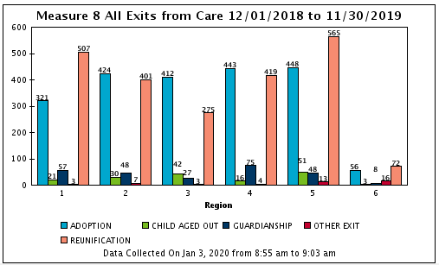

Measure 9 – Children in Care
- This measure includes total count of children in care - Point in time counts
- Total count of cases for those children (unique count)
- Count of children in supervision
- Total count of supervision cases for those children (unique count)
